Engagement and Support Officer

Job Description

Job Details
Responsible to: Director, Care Opinion Scotland
Location: The post holder will be based in the Stirling office. The post holder must be prepared for travel within the Central Belt and across Scotland as well as occasional travel to Head Offices in Sheffield.
Salary: Grade 4: £19,202
Benefits: 32 days holiday (28 flexible, 4 fixed) and your birthday as a holiday, generous pension scheme, Perkbox employee benefits scheme, family friendly employer

Job Purpose
Care Opinion is an independent, not for profit social enterprise with a small, committed and passionate team. Our mission is to make it safe and simple for everyone to share their experiences of health and care services in ways which connect people together for change. Inclusion, transparency, integrity and innovation are some of the values which drive what we do and how we do it.
In Scotland, the significant rise in use of Care Opinion has been identified by the Scottish Government as one of the key contributors to the person centred care quality ambition. Care Opinion is becoming an integral part of the feedback landscape across health in Scotland and our ambition is to extend that opportunity to people using all health and social care services across the country. There is still much to do.
The role of Engagement and Support officer is a key cog in our small but perfectly formed wheel! The purpose of this role is to:
- Support our newbie subscribing organisations and their staff at the start of their Care Opinion journey;
- Encourage our existing subscribing organisations and staff, helping them to navigate and make the most of all Care Opinion’s fantastic features;
- Offer an unfailingly positive customer service experience to everyone who comes into contact with Care Opinion;
The post holder will be able to demonstrate your passion for harnessing citizen voice in improving health and adult social care services and commitment to Care Opinion’s vision, mission and values.

Key role areas
- Providing quick and constructive support to customers on all issues relating to the effective use of Care Opinion;
- Handling queries from other organisations and the public via telephone or email in a friendly manner;
- Preparing and delivering excellent training to customers, face to face, via online tools;
- Actively engaging and supporting members of the public who want to share their experiences at events or via phone;
- Carefully moderating stories/responses and ensuring accurate and speedy publication;
- Contributing enthusiastically to sales and marketing planning and activity;
- Website administration: diligently updating services, maintaining subscriptions, developing and updating site pages;
- Proactively seeking customer feedback and using this to contribute to product and service development;
- Organising and participating in the delivery of informative subscriber, networking and awareness raising events;
- Actively contributing towards the maintenance of a high level social media presence eg Twitter, Facebook, Vimeo;
- Carrying out all those necessary little administrative tasks required!

Dimensions
- Customer service and support: using a range of mechanisms and skills to provide excellent customer service to subscribers and in engaging with the public and other key stakeholders;

- Training and presentation: using a range of face to face and online methods to deliver essential information effectively;

- Communication: engaging presence on social media, supporting subscribers with social media use, using a range of methods confidently and with skill, ie telephone, email, written reports;
- Working in a team: understanding business priorities and challenges, participating enthusiastically, readily undertaking duties which ensure smooth running of day to day business;
- Technical: website maintenance; information management, use of database, spreadsheets; able to demonstrate IT confidence;
- Organisation: leading event management and delivery;
- Evaluation: regularly assessing colleague and customer satisfaction, participating in self-evaluation through the review and appraisal system.

Person Specification

Criteria:
The post holder will be a confident and clear communicator who has a natural affinity for developing warm, positive, constructive and supportive working relationships not only as they provide excellent customer service but in their role as a member of a small team. Being able to work effectively with colleagues and people from a range of backgrounds and positions and commitment to citizen feedback is essential. An understanding of health and social care in Scotland would be an advantage
As part of a very small team, a flexible approach and the determination to do whatever it takes to get the job done is important.

Knowledge, skills and experience:
- Has 2-3 years significant work experience in a customer service, support, communications or training environment;
- Possesses relevant experience, either in a paid or unpaid, in a health or social care setting;
- Advanced IT, social media and online communication skills;
- Confident and clear communicator using a range of media effectively;
- Demonstrates outstanding customer service and relationship building skills;

- Well organised and has excellent planning skills;
- Displays confidence and ability in demonstrate software and business processes to others;
- Proven experience of website and database updating and maintenance;
- Effective and supportive team player;
- Works flexibly, demonstrating a high level of self-motivation, initiative and resourcefulness;
- Thrives under pressure and consistently delivers highest quality results
- Possesses a full, clean driving licence and the willingness and ability to travel throughout Scotland, and to Head Office in Sheffield, as required;
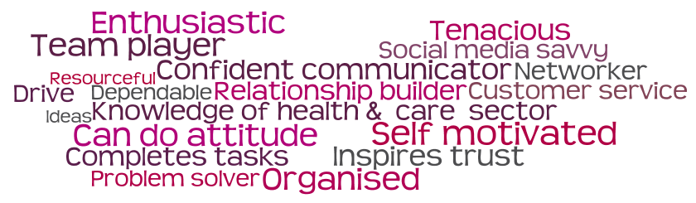
- Has a Degree or equivalent.

To apply:
To apply: If you are interested in this position, please complete and submit the online application form. If you would also like to submit your CV, you can do so via the online application.
Closing date: 9 am on Monday 14 October 2019

Selection will take place during week commencing 21 October.

