How to Post a Response to a Story

Patient Opinion sends you an email alert when a story relevant to your subscription is published. This email includes a link to the story; click this link to view the story on the Patient Opinion website where you will be automatically logged in.

For security reasons, this will only happen when you click the link the first time, if you click the link again or pass it on to someone; you will need to manually log yourself in again by clicking “log in” in the top right.

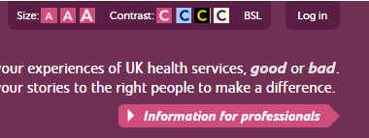

You can easily tell when you’re logged in as there will be a Yellow bar at the top of your screen.
If you are struggling to post a response and the yellow bar isn’t there, this means you need to log in.
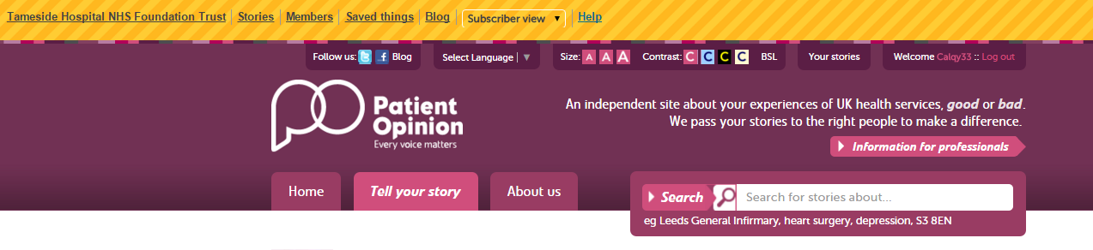
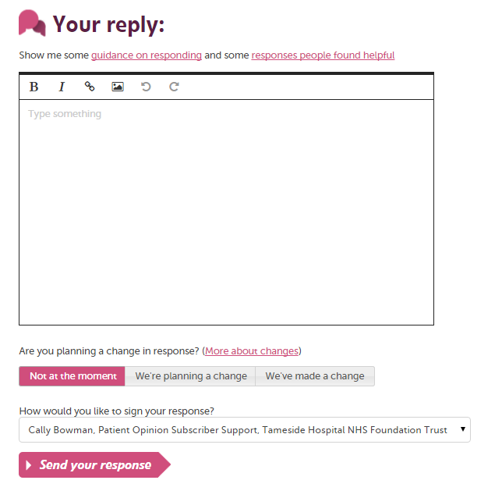
Once you have logged in and read the story, scroll down the page and underneath the story you will see a box that invites you to post “your reply” (shown below)

If you feel that you need some guidance there are two useful links above the box, alternatively you can read our blogs about responding for tips and advice.
You can use the options in the top of the box to alter the text, add a link or photo and undo/redo.

After writing your response, you have 3 options to choose regarding whether your response stated you were planning to make a change relevant to the feedback in the story, of if you already have; select “we’ve made a change”.

If not leave it as the “not at the moment” option. Select wisely though, don’t choose “we’re planning a change” if this isn’t true.
Finally press “Send your response” and you’ll see the green tick below. If not, or if you have any other questions– give us a call!
