Development Officer

Job Description

Job Details
Responsible to: Director, Care Opinion Scotland
Location: Based in the Stirling office. The post holder must be prepared for significant travel within the Central Belt and across Scotland as well as occasional travel to Head Offices in Sheffield.
Salary: Starting salary - £26,234 – 35 hours per week. We regard this as a full time role but would be prepared to be flexible for the right person.
Benefits: 32 days holiday (28 flexible, 4 fixed) and your birthday as a holiday, generous pension scheme, Perkbox employee benefits scheme, family friendly employer

Job Purpose
Care Opinion is an independent, not for profit social enterprise with a small, committed and passionate team. Our mission is to make it safe and simple for everyone to share their experiences of health and care services in ways which connect people together for change. Inclusion, transparency, integrity and innovation are some of the values which drive what we do and how we do it.
In Scotland, the significant rise in use of Care Opinion has been identified by the Scottish Government as one of the key contributors to the person centred care quality ambition. Care Opinion is becoming an integral part of the feedback landscape across health in Scotland and our ambition is to extend that opportunity to people using all health and social care services across the country. There is still much to do.
This role is pivotal in both developing our existing service and extending our work further across Scottish health and adult social care services.
The purpose of this job is:
- Developing and expanding the use of Care Opinion by engaging health and social care organisations as subscribers;
- Maintaining a positive profile for Care Opinion with health and social care organisations, citizens, key stakeholders, local and national government through the development and implementation of a comprehensive communication and networking strategy which provides a platform for sustained business and activity;
- Managing and delivering service level agreements and support for subscribing organisations.

You will have a passion for harnessing citizen voice in improving health and adult social care services. The post holder will be involved with key stakeholders including local authorities and need an awareness of appropriate political sensitivities. You must demonstrate commitment to Care Opinion’s vision, mission and values.

Key role areas
- Developing effective engagement plans which drive the profile and use of Care Opinion across health and social care;
- Engaging and supporting providers in the implementation and use of the integrated feedback platform;
- Initiating and leading improvement and development in all aspects of service delivery
- Developing and managing appropriate networks and contacts to support effective development and implementation;
- Ensuring the smooth running of day to day operations via moderation, subscriber support, development of effective resources and procedures, liaison with providers and the public;
- Monitoring and reporting on progress and performance against agreed deliverables;
- Proactively supporting sales process from initial enquiry to proposal and completion of service level agreement;
- Deputising for the Director as appropriate.

Dimensions
- Development: implementing and refining project plan, delivering on KPIs, acting as the sole representative of Care Opinion with providers and key stakeholders;
- Engagement: effective use a wide range of appropriate means to engage providers and stakeholders and staff at all levels with Care Opinion, eg presentations, training (face-to-face/online), arranging, managing and leading local/national events, producing written materials;
- Leadership: managing and leading projects and initiatives; modelling Care Opinion values; strategy development
- Support: delivering excellent training and follow up support, advice to providers in the optimum use of Care Opinion; dealing with provider and public queries;
- Partnership working and networking: establishing and maintaining positive working relationships with key stakeholders at local and national level across health and care;
- Marketing and sales: actively using social media and traditional media to promote awareness, developing site content and blogs, support the development of business model which will lead to future sales;
- Working in a team: timely moderating stories in line with policy, participating enthusiastically in regular meetings, readily undertaking duties which ensure smooth running of day to day business;
- Administration: initiating and maintaining necessary administrative processes;
- Evaluation and monitoring: regularly assessing customer satisfaction, continuously evaluating progress, supplying customer intelligence to product and service development.

Person Specification

Criteria:
To do this job effectively you will be committed to the principles of social enterprise and the mission, vision and values of Care Opinion. You will have good experience in health and adult social care fields as well as an excellent appreciation of the integration landscape in Scotland. You will be passionate about the role of citizen feedback in service improvement. Experience of leading and delivering successful projects is key, as is the ability to communicate confidently and clearly. You should be comfortable working in different situations with all kinds of people.
As part of a small team, a flexible approach and the determination to do whatever it takes to get the job done is important.

Knowledge, skills and experience:
- Relevant experience in a development role in health, social care, third sector or equivalent
- Confident and compelling communicator with excellent training and presentation skills
- Excellent organisational, administrative and IT skills
- Proven leadership and project management skills
- Demonstrates significant online profile and activity
- Excellent networking skills
- Thrives under pressure and consistently delivers highest quality results
- Works flexibly, demonstrating a high level of self-motivation, takes initiative and manages opportunities appropriately
- Strong and committed team player but also able to work in isolation
- Excellent understanding and avid user of social media and the web
- Sales and marketing knowledge and experience
- Own car and the willingness and ability to travel throughout Scotland, and to Head Office in Sheffield, as required
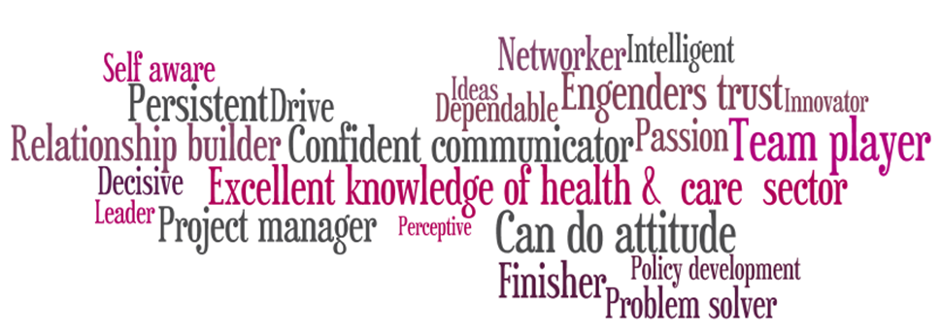
- Has degree or equivalent

To apply:
If you are interested in this position, please complete and submit the online application form. If you would also like to submit your CV, you can do so via the online application.
Closing date: 5pm on Monday 2 September 2019

Selection is scheduled to take place during weeks commencing 9 September 2019.

