What is an invitation link?
An invitation link is a way for you to ask for feedback about a specific service or issue. An invitation link is basically a URL link that takes the user straight to a simplified version of telling their story on Care Opinion, that is already linked to your chosen service.
An invitation link also gives you the option to generate a QR code and you can also link an external survey to it.
For example, you may wish to gather feedback about a diabetes outpatient clinic. You can create an invitation link for this specific service. This means that when the link is used, the diabetes outpatient clinic will already be linked to the person’s story.
You can also add tags to an invitation link. So using the example above, you could add the tag ‘Diabetes’ to the invitation link. Every story shared when using the link will then automatically be tagged with ‘diabetes’. This can make it easier for you to search and report on the stories at a later date.
An invitation link looks like this:
https://www.careopinion.org.uk/invitationlinks/test-link

You can also hyperlink it, like this:

We’d love to hear your feedback, click here to share your story with Care Opinion

How can I use an Invitation Link?

Invitation links can be added to most correspondence that you have with patients and/or service users. Here are some ideas:
- Emails
- Texts – appointment reminders etc
- Letters
- On staff email footers

Other features of an invitation link
QR Codes
Once you have created your invitation link, you will have the option to create a QR code. A QR code allows easy navigation to a pre-determined URL for anyone who has the use of a smartphone. As long as the location of the QR code is in an area with good mobile signal/internet connection, it can be a really useful tool. QR codes have successfully been used on posters in waiting areas for example.
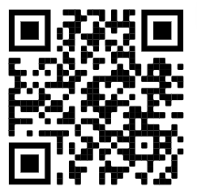
Key features:
- Simple to use for authors with smartphones.
- Can be used on a number of materials such as posters, leaflets, emails etc.

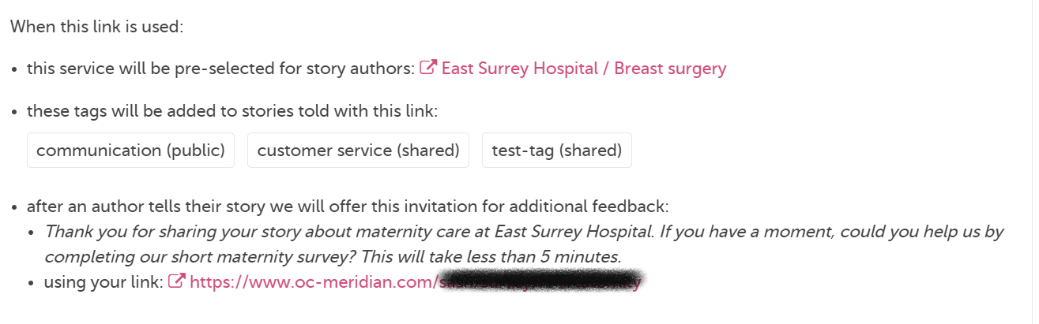
Here is an example of what an invitation link will do when it’s used by someone:

Sounds great! But how do I create one?
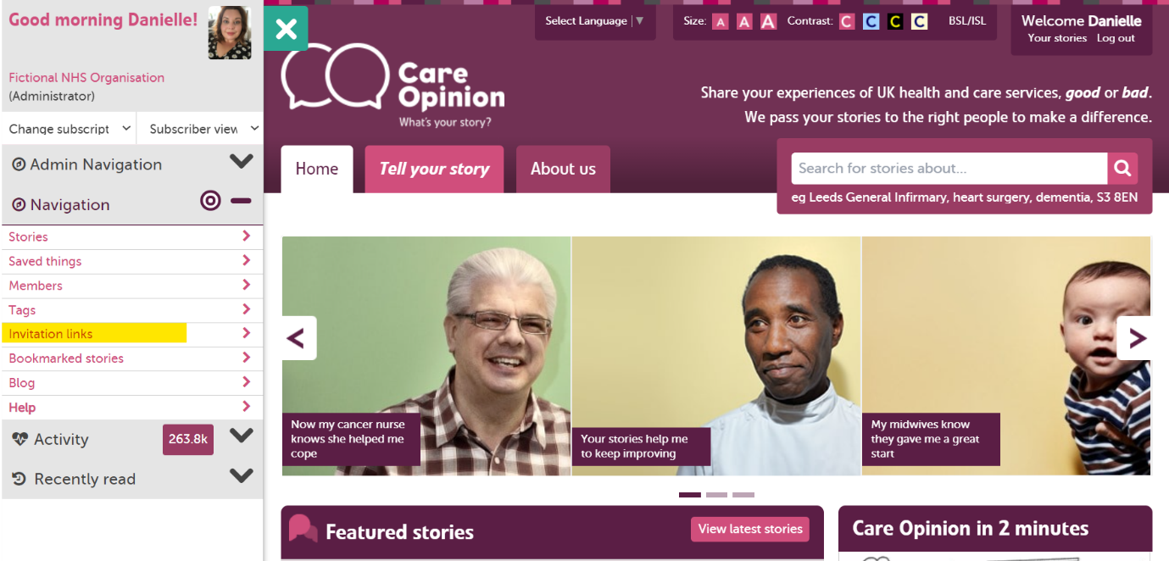
Then, in your navigation panel on the left of the screen, click “invitation links”
First, make sure that you’re logged in

You should now be looking at this page. Here is where you can find all of the invitation links that have been created previously.
To create a new invitation link, click on the “+ New invitation link” button
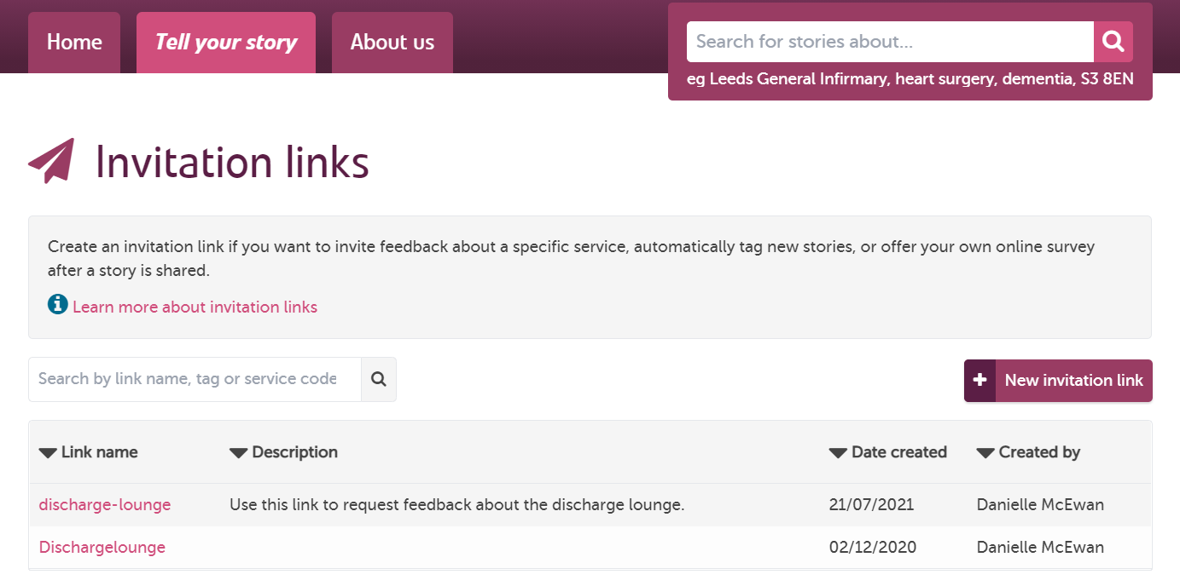
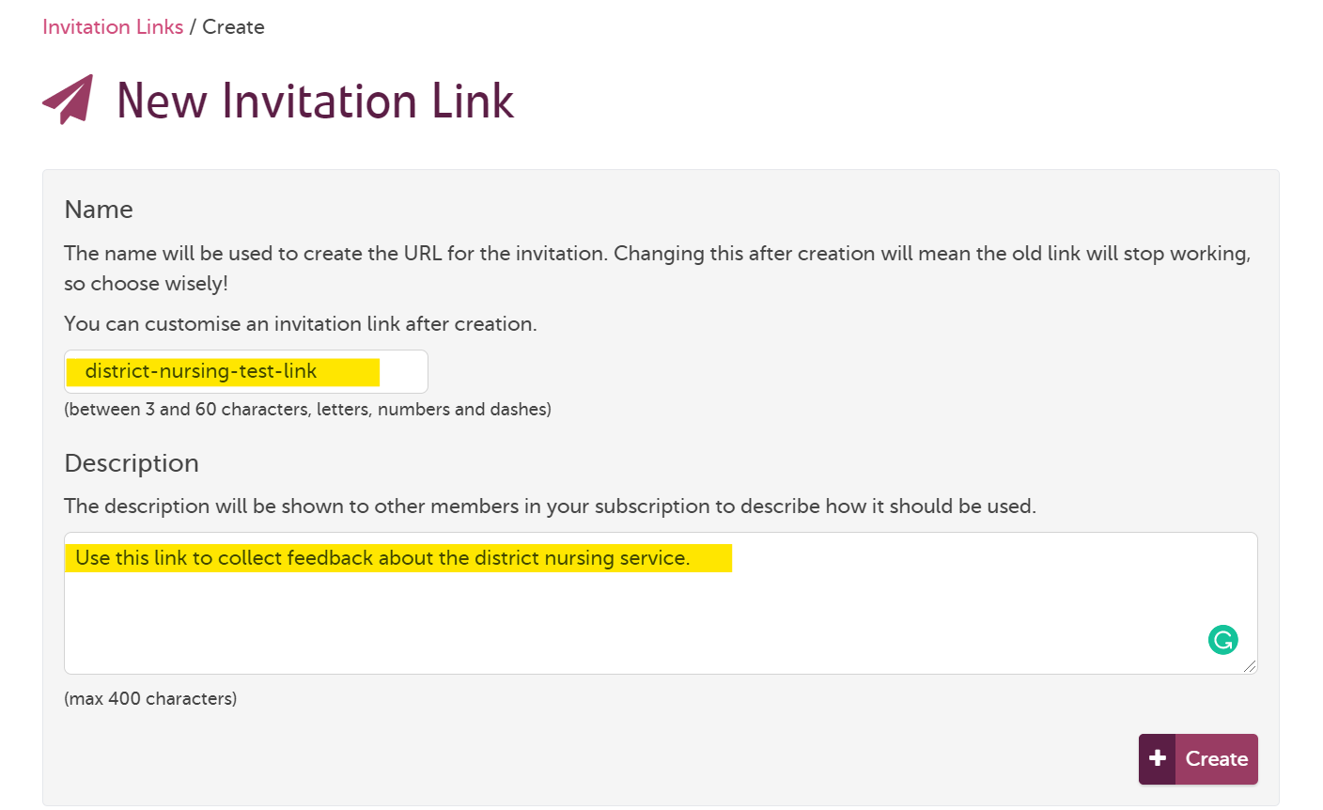
Now for the exciting part, naming your invitation link! This is what will form the end section of your invitation link and will be visible to anyone who uses it. You can see below we are naming this link “district-nursing-test-link”
In the description box, give more information about when the link should be used, or any other helpful tips. You can write anything in here, it will only be visible to those in your subscription.

Almost there! You have now created an invitation link! However, we still need to link a service to it. You can see from the warning message that some actions are still required.

We are going to start by clicking the “service to receive feedback”, highlighted below in yellow.
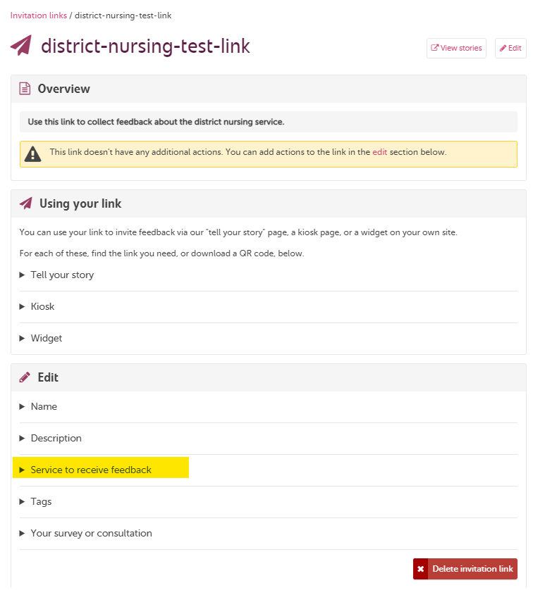

Type the name of your service in the “search for a service” box. A drop down menu with green + will then appear, like below: 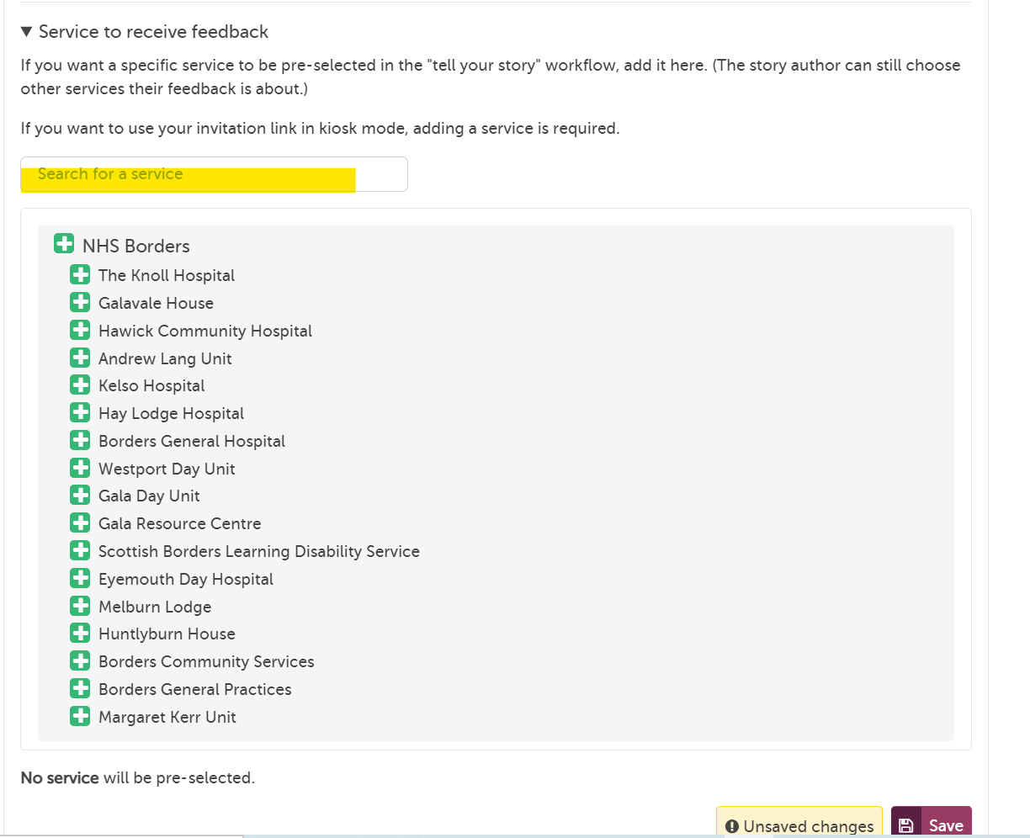
Click on the TITLE of the service to move further down the tree. Once you are happy that you have the right service, click the green +.
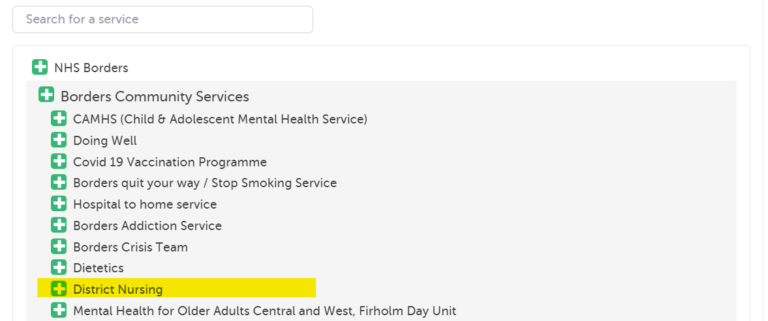

In this case, we’ve chosen the district nursing service.

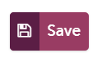
Remember to click the button!
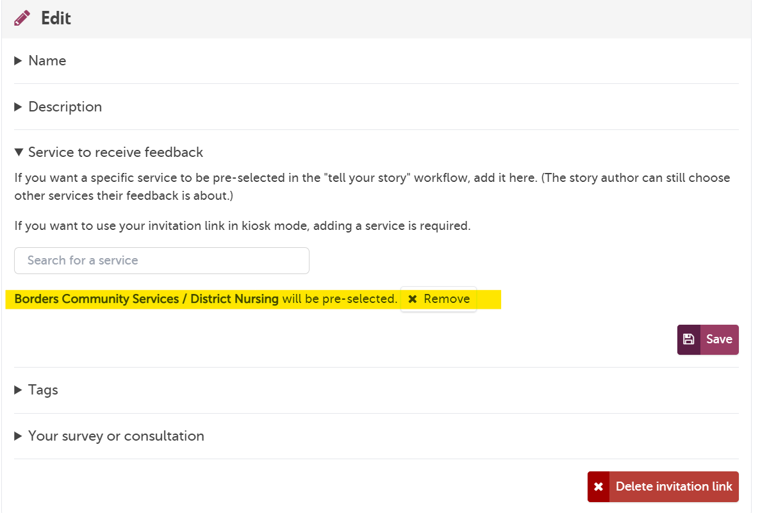

Great work! You can now see that the invitation link will automatically tag stories to the district nursing team.

Adding tags
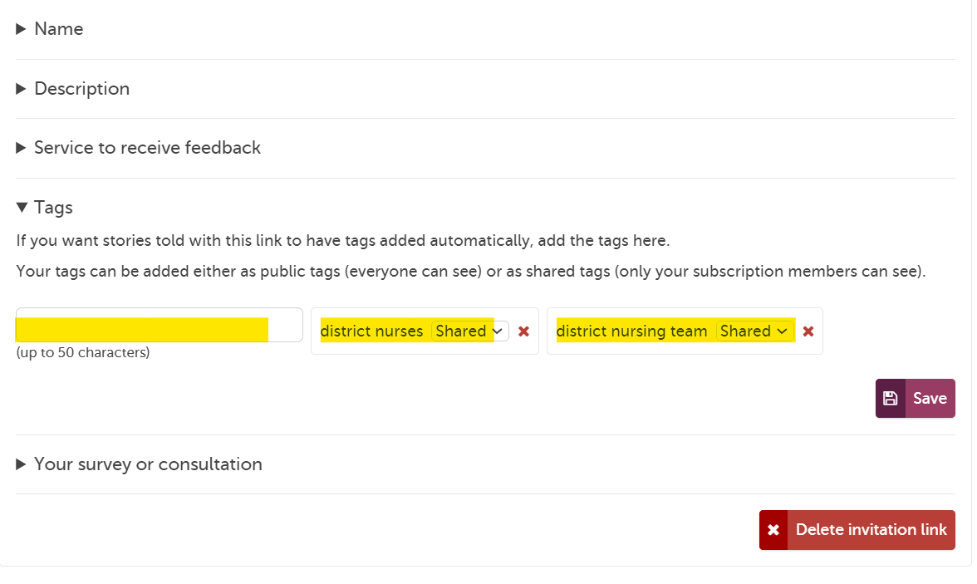
Click on the “tags” heading next, and start to add any tags you’d like to automatically link to stories. You can add as little or as many as you’d like.
When finished, remember to click the button!

Linking a survey
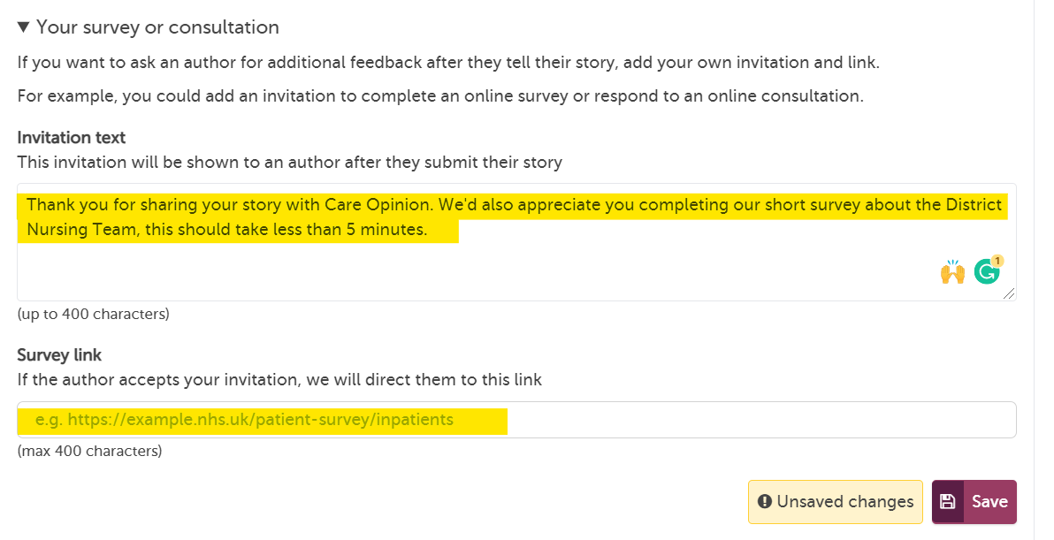
You may have a separate survey you are carrying out about the same service, and would like to link this to your invitation link. You can do this here. After the author has shared their story, the site will invite them to complete the survey, you can personalise the message that will be shown below:
Sharing your invitation link
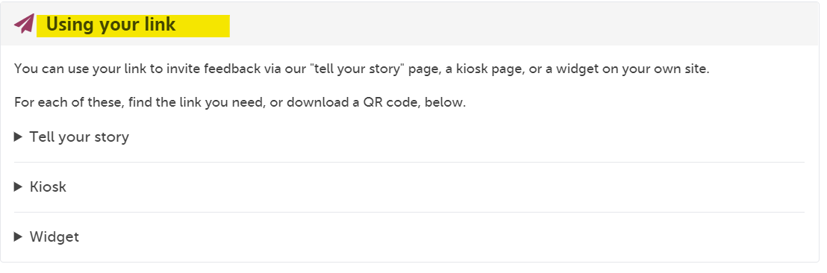
Congratulations! You should now have successfully created an invitation link! Now you can start sharing the link to generate more feedback.
Visit the “using your link” section. You will see that you have 3 options:
- Tell your story – here you can generate a QR code or copy the link to share
- Kiosk – here you can find a kiosk link for use with ipads etc
- Widget – code to add our "tell your story" widget to your own website

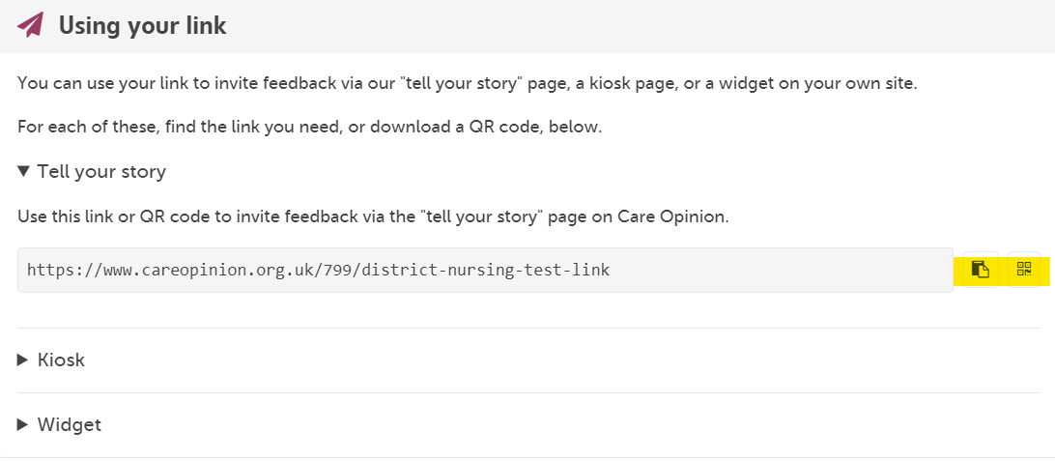
Use the buttons at the side to either copy your link, or generate a QR code. The site will give you a choice of QR code sizes which it will then download for you to use.

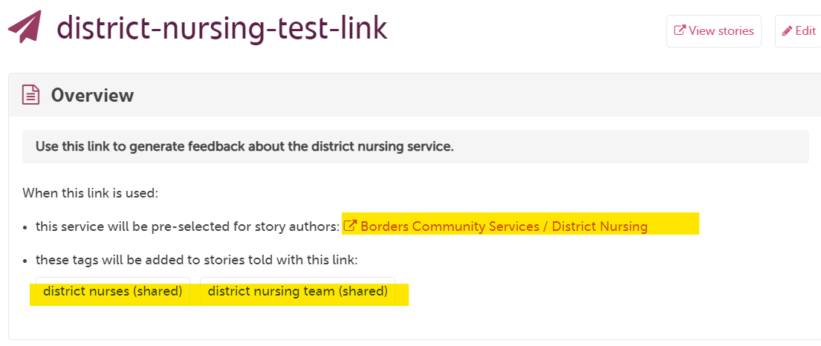
You can scroll up to the top of the page at any time to check the details of your invitation link:

Checking existing links, searching for stories and making changes
You can access existing invitation links from the navigation menu on the left hand side once you login.

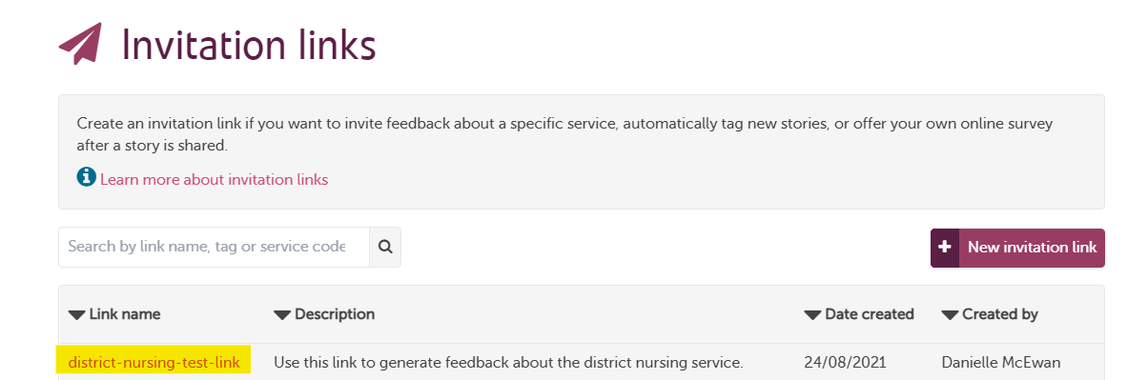

From here you can click on the chosen link name to make amendments or see stories that have been submitted using the link.
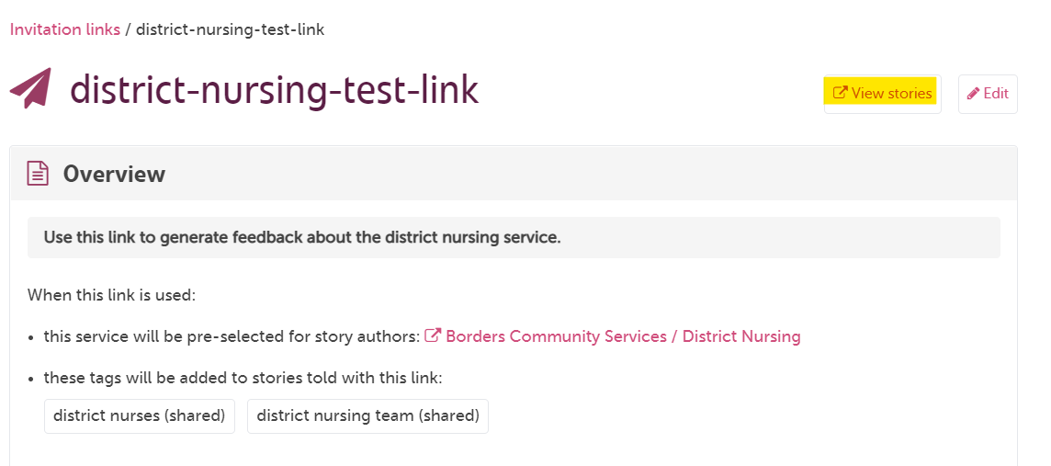

If you have any questions, please ask! We’re here to help. You can also head over to our ‘Subscriber know how’ page to get more help with managing your subscription and the features of the site.

The Care Opinion Team

