How to Respond to a Story on Care Opinion
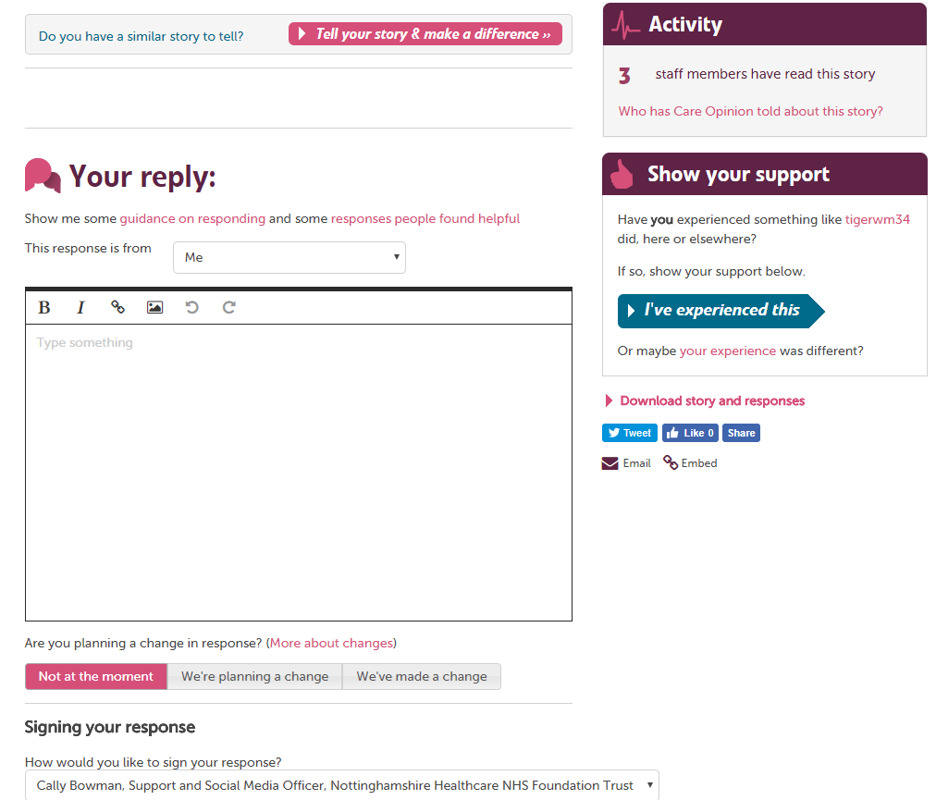
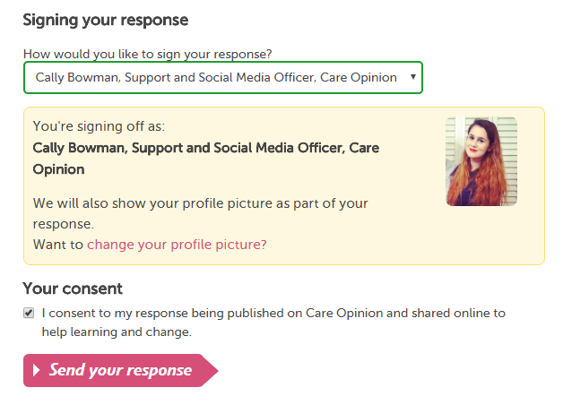
2 Key Requirements for posting a response:
1. To post a response, you must be a member of a subscription on Care Opinion and have responding access.
2. You must be logged into your Care Opinion account.
Once you are logged in and have clicked on the story that you would like to respond to, scroll to the bottom of the story and there will be a response box. If the box isn’t there, check that the 2 key requirements for posting a response have been met (see above). An easy way to know that you are not logged in, is to check for the yellow navigation bar at the top of the page, if the yellow bar is not there, then you are not logged in.
The response box will look like this:
Type your response in the box
You can add pictures or links here too. We have some helpful guidance for writing your response above the response box. Click the pink links to view, or join one of our webinars for more advice.
Showing that you are making a change
You have the option to add a marker to your response showing that you are planning to make a change/ that you have made a change because of the feedback in the story that you are responding to. If there is no change, then you don’t need to do anything as the “not at the moment” option is set as the default here. You can always post a further response in the future if anything changes.
Signing your response
You can then choose how you would like to sign your response (note that this appears at the top of your response and so we recommend signing off your response in the text box also). Using the drop down menu, select the option that you prefer. (we recommend the default option as it is more personal).
Submit your response
To submit your response we ask for you to consent to your response being published on the site, simply tick the box to do so, then click “send your response”.

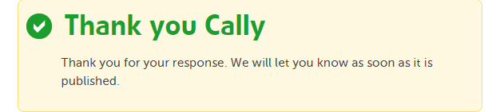
Moderation
Once you have submitted your response you will see a green tick. This means that we have received your response and is waiting to be moderated by the Care Opinion moderation team. Once the moderation team approve your response it will be published, and we will email you to let you know. We will also automatically email the author of the story to let them know that their story has a response.
If you require any further help or advice, please contact Care Opinion by phone or email.
Guidance for writing a response: What to include
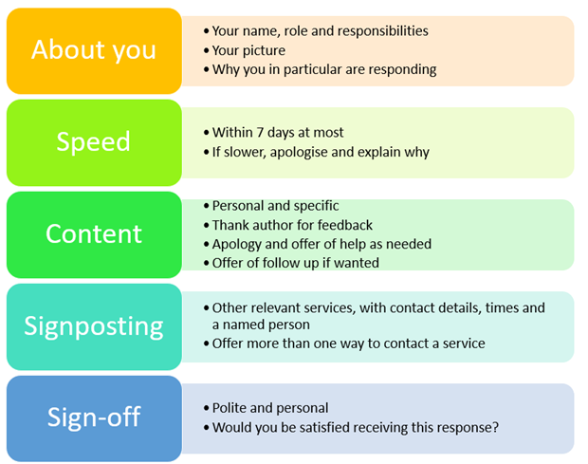
New research based on Care Opinion stories and responses has identified the five most important features to include in a helpful Care Opinion response. See the five features detailed in the table below. If you'd like more help or advice with responding to stories on Care Opinion, why not join our next "How To" webinar session, where we'll discuss different examples of responses and best practice. The session is part of our ongoing webinar programme, simply click the link to view the upcoming dates and register to join.

