Sample story
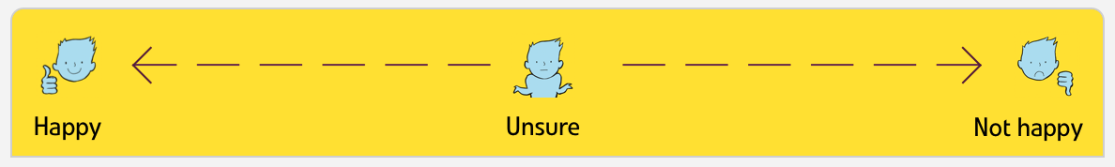
Overall very satisfied with care

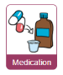
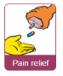
Overall I was very satisfied except for staff skills at taking blood and having to wait for pain relief.

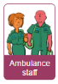
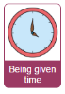
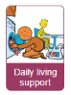
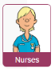
I was worried about how things were at home while I was in and at discharge I felt plans for the future could have been better.

