Introduction to Care Opinion

The website careopinion.org.uk is a place where people can share their experience of health or care services and help make them better for everyone.

Care Opinion makes it safe and simple to share stories online. All the stories are anonymous.

Who can share a story? | Anyone can share a story about their own experience of care or the experience of someone they care for, a friend or relative.  Staff, volunteers, and advocates are also able to share a story on behalf of a patient or service user.
How is it safe? | Care Opinion reads all stories before they are published. If the moderation team are worried for any reason about a story going onto our website, we might get in contact with the story author before we publish their story.
What happens next? | Staff who provide the service(s) will be invited to respond to a story, as well as other organisations who are involved  Story authors can feedback about multiple providers both health and social care. Members of the public are not able to respond to or comment on stories.

How can volunteers help?

Sometimes people who use services do not have access to the internet or they need support to tell their story. As a volunteer you can help put their story on the Care Opinion website.

How to help someone enter a story on the Care Opinion website

What do you need to get started?
- A device with access to the internet
- An account on Care Opinion so you can add stories from people that don’t have email addresses
- Access to a quiet place away from staff and other service users

Adding a story
Go to careopinion.org.uk and click or use the link provided by the service.

Follow the process on screen to add the story in the author’s own words. You will be asked to add a title and then the main story.

It will look something like this:
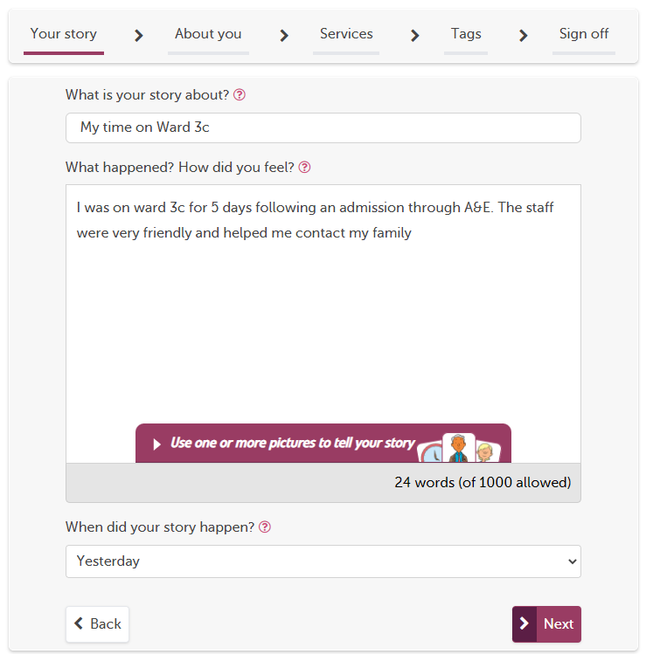

Does the author have their own email?

Before you start ask the person if they have their own email address. This effects how you will add the story:

Does the author have a postcode and email address they can use?
No
Yes
Make sure you are not logged in
Enter the story in the author’s words then select the role that best describes the author in the ‘About you’ section.

Follow the tell your story process and put in the author’s postcode and email address when prompted.

Then ask the author to create a username that is not their real name or use the username generator
Log into careopinion.org.uk and enter the story in the author’s words BUT then in the “About you section” the role of “a staff member posting on behalf of a patient/service user”
The story will be shared under your staff/volunteer account. If the story receives a reply you will need to share this with the author
The story will now be added under the author’s account to they will be directly emailed if they get a reply from services
Follow the tell your story process and put in the author’s postcode or the post code of the service

Check the author is happy for you to share the story on their behalf and submit.

Engaging with patients, service users and carers – A few points to consider:

Environment: Pick somewhere that feels comfortable for the author and yourself. If you can go somewhere quire and private this will help the story author, feel more like they can speak openly

Explanation: Explain to the story author why feedback is important to your organisation and offer an explanation of the Care Opinion website and how it works.

Introduction and conversations: Introduce yourself and explain why you are collecting feedback. Simple, open ended questions are really helpful, don’t be afraid to gentle nudge for the “why” the experience was good or not so. The most helpful stories are the ones that go into detail.

There is more information about all of these points in the link at the end of this document

Keeping it safe

Care Opinion is a public website for anonymous feedback. It is not for resolving on-going issues or formal complaints. As a volunteer, please make a decision about if the person wants to give feedback on Care Opinion or requires other support. You can involve your manager or the ward manager.

For managers, we have a short protocol to help handle these situations and other scenarios in our Volunteer Protocol For Safe Feedback:

https://www.careopinion.org.uk/info/guidance-supporting-volunteers

No Access to the internet?

If you don’t have access to the internet whilst speaking to people, you can download and print our Tell Your Story forms and upload the story later.

https://www.careopinion.org.uk/resources/site?id=taking-a-story-form.pdf

Remember you are collecting personal data. Please treat these forms in line with your organisation’s data protection policies. We strongly recommend destroying the forms after the story has been published on Care Opinion

A final note…
This toolkit is meant as a quick start guide.

Don’t forget there is a recorded webinar on volunteers: https://vimeo.com/468899023

See the full staff and volunteer overview https://www.careopinion.org.uk/info/staff-and-volunteer-overview

The Care Opinion Team are available to discuss in more detail any aspect of gathering stories or particular challenges for your organisation.

Please contact your lead at Care Opinion or info@careopinion.org.uk

